Document Reference: |  | DSBU Global Services Project Portal\HENKEL AG & Co. KGaA\SOW\ Henkel - Statement of Work_Rollout_V0.1.docx
Version: |  | 0.3
Last updated by: |  | Wendy Huo
Date: |  | 04 Jul 2025
Status: |  | In Review

HENKEL AG & Co. KGaA
Statement of Work
SampleManager Rollout

Revision History
Version | Date | Author | Notes
0.1 | 20-Jun-25 | Wendy | Created initial draft
0.2 | 24-Jun-25 | Tracy/Nishi/Shravan/Wendy | Reviewed and modified
0.3 | 04-Jul-25 | Wendy | Modification on splitting Phase 1 into sub-phases Phase 1A & Phase 1B

Table of Contents
1 Summary 5
1.1 Definitions 5
1.2 References 5
1.2.1 Service Provider References 5
1.2.2 Henkel References 6
2 Background 7
2.1 Project background 7
3 Services to be provided 8
3.1 Scope of Services 8
3.1.1 Time and Materials Services 8
3.1.2 Out of Scope 9
3.1.3 Environments 10
3.2 Location of Services 11
3.3 Deliverables 11
3.4 Project Closure 11
3.5 Project Implementation 11
3.5.1 Project Approach 11
3.5.2 Project Organization 12
3.5.3 Project Execution Methodology 12
3.5.4 Project Phases 13
3.5.5 Project Initiation 17
3.6 Schedule 17
3.7 Static Data 18
3.8 User Acceptance Testing 18
3.9 Project Controls 19
3.9.1 Issue Management 19
3.9.2 Actions 19
3.9.3 Decisions 19
3.9.4 Lessons 19
3.10 Acceptance Criteria 19
3.11 Completion Acceptance Procedure 19
3.12 Change Control 20
3.13 Dependencies, Assumptions & Constraints 20
3.14 Roles and Responsibilities 22
3.14.1 Service Provider Responsibilities 22
3.14.2 Customer Responsibilities 23
3.14.3 Project and Business as Usual Roles 25
4 Communication Plan 26
4.1 Communication & Reporting 26
4.2 Escalation Procedure 27
5 Term 28
6 Charges 29
6.1 Consultancy Fees 29
6.2 Travel 30
6.3 Expenses 30
7 Acceptance 31
Appendix A – Delivery Acceptance Form Template 32
Appendix B – Change Request Template 35

Summary
This Statement of Work is made on 20 Jun 2025 between:
Thermo Fisher Scientific (“Service Provider”); and
HENKEL AG & Co. KGaA, a business and having its registered address at Henkelstraße 67, 40589 Düsseldorf, Germany
This Statement of Work is issued pursuant to, and incorporates and is governed by, the Master License Agreement (“MLA”) between Thermo LabSystems Inc. and the Customer dated TBD and sets forth the specific terms and conditions relating to the provision of Services referred to in this Statement of Work. The combination of the terms of the MLA and the provisions of this Statement of Work shall together constitute the agreement between the Parties in respect of the Services (the “Agreement”). Terms used but not otherwise defined herein shall have the definitions given to them in the MLA.
In the event of any discrepancy between the provisions of the MLA and the Statement of Work, the provisions of the MLA shall apply.
The terms and provisions of this Statement of Work constitutes the agreement between the Parties in respect of the Services (the “Agreement”).
NOW THEREFORE IT IS HEREBY AGREED as follows:
Service Provider agrees to provide the Services as set out in this Statement of Work.

Definitions
The following terms have the meanings shown through this SOW:
Term/  Abbreviation | Meaning | Description
SOW | Statement of Work | This document; a formal document that provides a detailed description of the services or tasks a supplier is required to perform under contract.
SOP | Standard Operating Procedures | Written procedures [maintained as a controlled document] prescribing and describing the steps to be taken in normal and defined conditions which are necessary to assure control of development and processes.
QCLAD | Quality Control Lab Digitalization | LIMS (SampleManager) system implemented at Henkel Dragon site.
SFS | Smart Factory System
PMO | Project Management Office | Thermo Fisher Organization to ensure that project processes and quality are met our global standard.

References

Service Provider References
The following references to Service Provider sources are made in this document.
Ref. No. | Reference | Description

Henkel References
The following references to HENKEL sources are made in this document.
Ref. No. | Reference | Description
1 | QCLAD SCALEUP 2025_APAC.pdf | APAC five site details and high level scope

Background

Project background
This project aims to rollout QCLAD (SampleManager) system to 5 other sites in APAC in two batches. The system will be rollout in phases across five factories in the APAC region, with Phase 1 divided into two sub-phases:
- Phase 1A: Songdo (South Korea), Waigaoqiao (China), and Kunpeng (China).
- Phase 1B: Humen (China) and Danyang (China).

Services to be provided

Scope of Services

Time and Materials Services
The scope of Phase 1 is divided into two sub-phases (Phase 1A: Songdo (South Korea), Waigaoqiao (China), Kunpeng (China); Phase 1B: Humen (China), Danyang (China)). Total services is the provision of 155 days of consultancy on a time and materials basis with Phase 1A 111 days and Phase 1B 44 days. These days will be utilized for the activities outlined in the list below, however this is not a definitive or fixed list and can be adjusted to meet the needs of the project, as agreed and communicated by the Project Managers in written (email or meeting minutes), providing that the number of days in scope is not exceeded. Any increase in days is subject to the Change Control procedure defined in section 3.14.
Thermo Fisher will generate two separate POs (Purchase Orders) corresponding to the two sub-phases. Activities for Phase 1B will be initiated only upon receipt of the PO from Henkel.
The scope of the delivery is assuming seamless replication of the system deployed in pilot plant across Henkel factories with no gaps. Therefore, Thermo Fisher's responsibilities are strictly limited to the activities specified in the table below, excluding any additional functional requirements.
As this is a collaborative project between both parties:
- Thermo Fisher will only conduct testing and issue resolution for tasks under its assigned scope of work.
- Testing and problem fixing for Henkel's responsible tasks fall outside Thermo Fisher's obligations.
- Each party maintains full responsibility for their respective deliverables.
If the Gap Analysis conducted by Henkel identifies discrepancies between the existing system and the target factories’ business requirements, and additional effort is required from Thermo Fisher for bridging these gaps. The associated effort required for such adjustments will be treated as a Change Request and documented separately from the below table.
The anticipated activities to be undertaken majorly by Thermo Fisher are defined as follows Henkel may get involved during instrument integration and language pack setup to get insight of the config , which will help Henkel team to take up additional instrument integration activities.
Rollout Phase 1 Scope (Split into Phase 1A & Phase 1B)
Phase 1A (Songdo, Waigaoqiao, Kunpeng)
Tasks | Effort Rollout
Kick-off & General Project Effort | 1
Instrument Survey and document update | 3
Static data assistance (non SAP) | 3
Thermo Fisher: Songdo Korean Language pack support/Train  (Henkel does the translation following Thermo Fisher guidance) | 5
Instrument Integration x 34 - – develop the parser to transfer the result data. Assist to establish the connection between instrument and SampleManager and end to end testing.  Type A: 6  Type B: 28 | 76
Sweeper and gateway installation and setup | 2
Printer configuration with lab collector | 1
Global Project Management | 4
China Project Management | 16
Total Days (Rollout Phase) | 111

Phase 1B (Humen, Danyang)
Tasks | Effort Rollout
Instrument Survey and document update | 2
Static data assistance (non SAP) | 2
Instrument Integration x 11 - – develop the parser to transfer the result data. Assist to establish the connection between instrument and SampleManager and end to end testing.  Type A: 2  Type B: 9 | 25
Sweeper and gateway installation and setup | 1
Printer configuration with lab collector | 1
Global Project Management | 3
China Project Management | 10
Total Days (Rollout Phase) | 44

Out of Scope
The following areas are out of scope for the activities covered by this project:
- Conducting a gap analysis and addressing any identified gaps.
- Modifications to existing configurations/development or implementation of new workflows, reports, labels and Dashboards.
- Assistance for Basic configuration for Stock, Scheduler, Instrument calibration setup, Folder, and Roles and Groups, Location, customer, units, operator etc.
- Modifications to the interfaces of SAP or MES.
- Thermo Fisher is not responsible for troubleshooting or resolving issues related to Henkel's responsible deliverables.
- The System Integration Testing, and the support to UAT.
- Thermo Fisher will only perform testing for tasks under its responsibility, such as the instrument integration assigned to Thermo Fisher. Testing of instrument integration assigned to Henkel falls outside the scope of Thermo Fisher's obligations.
- Go Live hypercare.
- During Rollout Level 1 and 2 support will be the responsibility of Henkel. Providing support is out of Thermo Fisher’s scope. Thermo Fisher is responsible for QCLAD issues fixing.
- Installation of Database including development/ production system.
- Hardware (Server, Clients, Network, etc.) procurement and deployment, in this case Henkel private cloud environment preparation.
- Installation of Operating System on Server and Clients.
- Supply of cables for serial instrument connections.
- Hardware maintenance/installation/network connection and support for label printer and scanner are out of in the project scope, these should be in the responsibilities of hardware suppliers or customer IT.
- HENKEL will have their own team to manage the project and hence Henkel’s project management and Henkel’s business change management are out of scope.
- Data is assumed to be cleaned before migration and hence data cleansing is out of scope.
- Process and procedure documentation is out of scope for Thermo Fisher.
- Management of the Henkel Data Centre [or Henkel third party provider] for hosting the LIMS platform if not hosted by Service Provider – assume all Henkel Technology Services will manage all Henkel Data Centre requests.
- Network and Infrastructure setup.
- Instrument Vendors engagement- Instrument Vendors engagement for any issues with the vendor's application, should be managed with the instrument vendor and Henkel. Thermo Fisher team will provide guidance on the technicality of instrument connectivity and interfacing if needed.
- Integration of instruments other than mentioned in the scope of this project, Henkel team will be able to integrate once they complete the Instrument Integration / Sweeper training.
- Good Manufacturing Practice (GMP) is not the scope of the project.
- Any documentation for instrument integration, language setup and other config if any

Environments

The Phase 1 implementation will retain the same hosted environment architecture as the Pilot phase, without any alterations. Additionally, the client-side and tablet configurations for the target factories will follow the existing requirements.
During Rollout, Henkel will supply separated lab collector servers for Sweeper and Gateway installation.

Location of Services
The services will be provided remotely, at the Customer premises and at the Service Provider’s premises.
The Service Provider will always provide the best resource available to undertake the services defined in this SOW. As the Service Provider operates a global pool of resources and the priority is to match skills and experience to the role required, the best match may not be a resource located locally to the Customer location. However, the Service Provider will endeavour to employ resources local to the Customer location whenever possible.

Deliverables
The Service Provider may engage one or more of its approved partners to produce any of the deliverables defined in this SOW. The Service Provider shall in all cases remain primarily responsible to produce the deliverable and ensuring that Service Provider's obligations under this SOW are met.
This SOW exclusively covers Rollout Phase for plants: Waigaoqiao, Kunpeng, Humen, Danyang, Songdo of the project. It encompasses the delivery of 155 consultancy/management days for Rollout Phase1 with 111 days for Phase 1A & 44 days for Phase 1B.

Project Closure
The Service Provider will assist the Customer with project closure activities as defined in the Scope section above.

Project Implementation

Project Approach
The approach is based upon industry best practice and is built upon extensive Thermo Fisher experience in SampleManager rollout. The approach can be aligned with Henkel procedure for a consolidated set of key governance processes, artefacts and metrics.
We will replicate Dragon site configuration to all the rollouts..:

- Any configuration update requires Change request.

Project Organization
We will maintain the same project organizational structure during the rollout phase as implemented during the pilot stage. Global resources will be involved for Korea rollout and Technical support.
While Henkel may not require the same comprehensive level of service as during the pilot phase, we have retained our full project organizational structure to ensure service readiness. Should additional support be needed, Henkel may initiate a Change Request, and Thermo Fisher stands ready to provide all necessary services at the required level.
Thermo Fisher and Henkel Project Managers will discuss and finalise the RACI matrix before the kick-off of the Rollout.

Project Execution Methodology
The project will adhere to the Service Provider's established processes and approach to QCLAD Rollout. The Service Provider will retain the original Pilot team to ensure continuity and efficiency for Rollout Phase. This team has in-depth familiarity with Henkel’s QCLAD system, enabling them to:
- Leverage Pilot-phase experience to provide swift support and issue resolution during the Rollout.
- Maintain strong collaboration, as Thermo Fisher and Henkel teams have already established a smooth working dynamic during the Pilot.
This approach ensures a seamless and well-coordinated expansion.
The project will primarily adopt an Agile methodology. Key practices include:
- Sprint Planning: Henkel and Thermo Fisher collaboratively define the scope and priorities for each sprint, ensuring flexibility to adjust tasks and focus on high-priority deliverables for timely deployment.
- Sprint Execution (Daily Meeting): Work is executed iteratively to guarantee the successful completion of each sprint.
- Sprint Review: After each sprint, a joint review meeting is held to evaluate completed deliverables and align on next steps.
- Sprint Retrospective: Both teams reflect on lessons learned to continuously improve subsequent sprints, driving steady progress.

This approach will help to ensure fast turnaround on delivery and accurate effort estimates for implementation.

Project Phases
First Batch Rollout – Phase 1 is divided into two sub-phases: Phase 1A & Phase 1B
Where Thermo Fisher will assist Henkel in deploying the QCLAD system—already successfully implemented in the Pilot plant—to five additional plants across China and South Korea in batches, including:
- Phase 1A: Songdo (South Korea), Waigaoqiao (China), Kunpeng (China)
- Phase 1B: Humen (China), Danyang (China)
The deployment will follow the same standardized approach used in the Pilot phase, ensuring consistency and operational efficiency.

The tasks to be executed by Thermo Fisher and the necessary efforts is evaluated for Phase 1, and any required support will be delivered via Change Request.

The below tasks and distribution are split into Phase 1, and divided into two sub-Phases:

Phase 1A
Sites | Tasks | Responsibility
All | Kick-off & General Project Effort | Thermo Fisher
Phase 1A sites | Gap requirements analysis after Henkel provides the gap report | Henkel
Phase 1A sites | Instrument Survey and document update | Thermo Fisher
Waigaoqiao | Basic configuration for Stock, Scheduler, Instrument calibration setup, Folder, and Roles and Groups, Location, customer, units, operator etc. | Henkel
 | Basic configuration for Stock, Scheduler, Instrument calibration setup, Folder, and Roles and Groups, Location, customer, units, operator etc. | Henkel
 | Workflows | Henkel
 | Reports, Labels and Dashboards site specific config | Henkel
 | Static data assistance (non SAP) | Thermo Fisher
 | SAP/MES site level mapping for the site and testing of workflows to ensure new mapping is working as expected | Henkel
 | Unit/smoke testing | Henkel
 | UAT and UAT Support | Henkel
 | Deployment on Prod and hypercare | Henkel
Kungpeng | Basic configuration for Stock, Scheduler, Instrument calibration setup, Folder, and Roles and Groups, Location, customer, units, operator etc. | Henkel
 | Basic configuration for Stock, Scheduler, Instrument calibration setup, Folder, and Roles and Groups, Location, customer, units, operator etc. | Henkel
 | Workflows | Henkel
 | Reports, Labels and Dashboards site specific config | Henkel
 | Static data assistance (non SAP) | Thermo Fisher
 | SAP site level mapping for the site and testing of workflows to ensure new mapping is working as expected | Henkel
 | Unit/smoke testing | Henkel
 | UAT and UAT Support | Henkel
 | Deployment on Prod and hypercare | Henkel
Songdo | Basic configuration for Stock, Scheduler, Instrument calibration setup, Folder, and Roles and Groups, Location, customer, units, operator etc. | Henkel
 | Workflows x1 | Henkel
 | Reports, Labels and Dashboards | Henkel
 | Static data assistance (non SAP) | Thermo Fisher
 | SAP site level mapping for the site and testing of workflows to ensure new mapping is working as expected | Henkel
 | Language pack config and support | Thermo Fisher/Henkel
 | Unit/smoke testing | Henkel
 | UAT and UAT Support | Henkel
 | Deployment on Prod and hypercare | Henkel
Phase 1A sites | Instrument Integration x 34  Type A: 6  Type B: 28 | Thermo Fisher
Phase 1A sites | Sweeper and gateway installation and setup | Thermo Fisher
Phase 1A sites | Printer configuration with lab collector | Thermo Fisher
Phase 1A sites | Project Management | Thermo Fisher
Phase 1A sites | Global Project Management | Thermo Fisher

Phase 1B
Sites | Tasks | Responsibility
Phase 1B sites | Gap requirements analysis after Henkel provides the gap report | Henkel
Phase 1B sites | Instrument Survey and document update | Thermo Fisher
Humen | Basic configuration for Stock, Scheduler, Instrument calibration setup, Folder, and Roles and Groups, Location, customer, units, operator etc. | Henkel
 | Workflows | Henkel
 | Reports, Labels and Dashboards | Henkel
 | Static data assistance (non SAP) | Thermo Fisher
 | SAP site level mapping for the site and testing of workflows to ensure new mapping is working as expected | Henkel
 | Unit/smoke testing | Henkel
 | UAT and UAT Support | Henkel
 | Deployment on Prod and hypercare | Henkel
Danyang | Basic configuration for Stock, Scheduler, Instrument calibration setup, Folder, and Roles and Groups, Location, customer, units, operator etc. | Henkel
 | Workflows | Henkel
 | Reports, Labels and Dashboards | Henkel
 | Static data assistance (non SAP) | Thermo Fisher
 | SAP site level mapping for the site and testing of workflows to ensure new mapping is working as expected | Henkel
 | Unit/smoke testing | Henkel
 | UAT and UAT Support | Henkel
 | Deployment on Prod and hypercare | Henkel
Phase 1B sites | Instrument Integration x 11  Type A: 2  Type B: 9 | Thermo Fisher
Phase 1B sites | Sweeper and gateway installation and setup | Thermo Fisher
Phase 1B sites | Printer configuration with lab collector | Thermo Fisher
Phase 1B sites | Project Management | Thermo Fisher
Phase 1B sites | Global Project Management | Thermo Fisher

Project Initiation
As an initial step in preparation for the project, the project governance and organisation structure is proposed. Tasks included are shown in Table below.
Task | Description
Project Governance and organization Structure | Define the Project Board members, Roles and Responsibilities  as well as the schedule of regular Project Board Meetings.
Project Team Meetings | Schedule project team meetings, as well as attendees and  base agenda. Set expectation of outcomes.
Project Reporting  Schedule and Format | Schedule for Project Reporting, Recipients with Report Format  and Content.
Deliverable Management | Process for managing deliverables. Expected delivery format  and acceptance criteria.
Risk Management | Approach to risk management. Establish the risk register, followed by an initial risk workshop to define project risks,  qualify the risks and identify mitigation approach and owners.
Project Dependencies | What dependencies exist and how will they be managed.
Project Plan | Establish initial project plan through the initial workshop phase. Identify resourcing and level out. Publish the initial  plan.
Budget Management | Establish the initial project budget, agreed with stakeholders and sponsors. Publish the budget detail. Budget will be managed and tracked throughout the project and will be aligned with any subsequent change control, or business case management.
Lessons Log | Establish the lessons log and agree the process for capturing, reviewing, and implementing corrective actions during the  project delivery phase.
Project Initiation Meeting | Hold the project initiation meeting to formally launch the project and communicate the project overview and governance to the wider stakeholder group and project teams.

Schedule
A tentative schedule for implementation is provided below, assuming there’s no gap implementation needed for the sites:
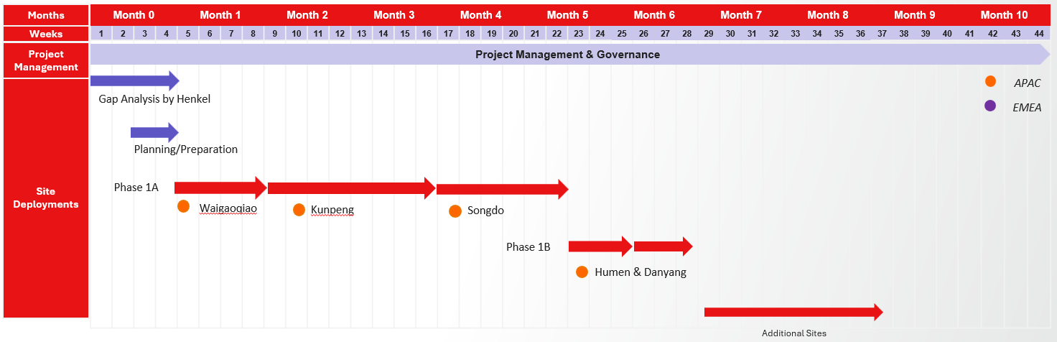
The deployment will be conducted site by site. Our Project schedule assumes that hardware is in place and that the Customer’s resources are available. At this stage this is a purely indicative schedule based on the information and estimates available at this time and has not been optimised to factor in weekends, holidays etc. This indicative schedule is subject to change as the project progresses and detailed plans are developed for each stage. This schedule will be reviewed and revised as appropriate at the start and at relevant points throughout the duration of the project.
The revised schedule will always be planned to take account of weekends, public holidays and other events, to ensure that workshops and training sessions always run on consecutive working days, e.g. not starting a 3-day workshop on a Friday.
Please note that this schedule is also dependent on the relevant approvals and purchase order being in place and therefore any delay in signing this SOW or providing the purchase could result in the rescheduling of the project.
Sprints will be tracked regularly, and any scope/timeline change will be taken care of via a CR. During the project life cycle, risks and issues will be identified, and a mitigation plan and contingency plan will be developed to address them. Any delay because of technical complexity or dependencies will be communicated to the team in advance. In those cases, Henkel's and Thermo Fisher’s PM will work together to get approval from management and extend the timeline.
In the event Thermo Fisher fails to meet any deadline or milestone set forth in this Agreement, Thermo Fisher shall immediately notify Henkel in writing of any anticipated delays and the reasons therefor. Such delays shall be addressed as well through the agreed Escalation Procedure (see 4.2 Escalation).

Static Data
Through the Pilot phase, Henkel has gained sufficient expertise in static data requirements under QCLAD and is now fully capable of performing master data creation and cleanup independently.
Therefore, during the Rollout phase, Henkel will take ownership of static data preparation for all rollout sites. Thermo Fisher will remain available to provide support and guidance as needed.

User Acceptance Testing
During Rollout, at the end of each sprint, the configuration/development is transferred to the UAT system.
UAT testing will be conducted by Henkel to ensure that the additional functionality brought in does not impact the existing system. This can be done on a risk-based approach where the only impacted areas are in scope for the regression testing. Thermo Fisher will advise Henkel on which areas are at risk from any changes made during each sprint.

Project Controls
Service Provider will maintain the usage data of the number of days used and will report actual usage and projected usage as part of the Communication and Reporting plan as detailed in Section 4.1.
Service Provider will maintain a risk register of the risks associated with the Service Provider delivery. This will be included in the Communication and Reporting plan as detailed in Section 4.1

Issue Management
Issue Management will be the responsibility of the project manager, however, the process of recording and assessing issues (and subsequent management) will be undertaken by the Service Provider Project Manager. All issues will be captured on the project issue log, with details of the priority, owner and actions to resolve. The issues will be reviewed by the joint project team as part of the project status and review meetings.
If issues require escalation, then the escalation process defined in Section 4.2 will be invoked.

Actions
A list of all actions that are agreed during meetings, workshops, and calls, together with details of those responsible and current status will be recorded and monitored.

Decisions
Details of all of the decisions made during the project will be recorded in a decision log.

Lessons
Throughout the project, a record of what went well and what went badly will be maintained in the lessons learned section of the project log. Everyone involved in the project will be encouraged to inform the Service Provider Project Manager about any lessons learned so that they can be added to the log.

Acceptance Criteria
Deliverable Type | Acceptance Criteria | Formal Acceptance Needed? | Process for Acceptance
Technical Work | Delivery Acceptance Form | Yes | Via Adobe Sign
PM Reports, Informal documents | Email report template | No | Email Acknowledgement

Completion Acceptance Procedure
Acceptance of the completion of the services defined within this SOW will be confirmed by the completion and signature of the Delivery Acceptance Form by the customer representatives who are authorized to accept on behalf of the customer. Please see Appendix A for the Delivery Acceptance Form template.

Change Control
The following process will be followed if a change to this engagement is required:
- A Change Request (CR) will be the vehicle for communicating change. The CR must describe the change, the rationale for the change, and the effect the change will have on the project.
- The designated Project Manager of the requesting party (Customer or Service Provider) will review the proposed change and determine whether to submit the request to the other party.
- Both Project Managers will review the proposed change and approve it for further investigation or reject it. Service Provider and Customer will mutually agree upon charges for such investigation, which may require an additional purchase order, if any. If the investigation is authorized, the Customer Project Managers will sign the CR, which will constitute approval for the investigation charges. Service Provider will invoice Customer for any such charges. The investigation will determine the effect that the implementation of the CR will have on SOW price, schedule and other terms and conditions of the Agreement.
- Upon completion of the investigation, both parties will review the impact of the proposed change and, if mutually agreed, a Change Authorization will be executed.
- A written Change Authorization and/or CR must be approved by both parties to authorize implementation of the investigated changes – please see Appendix B for the Change Request template. Approval needs to be in the form of a mutually signed (can be via e-signature) copy of the Change Authorization/CR, which will be documented as an Amendment to this Statement of Work.
- Change Request criteria which can be revised during the initiation phase.
Criteria | Action
Additional effort required because of complex task which was not expected during initial estimation. | Align with Henkel team and discuss the additional cost, effort and timeline required for the change request.
Additional effort because of the multiple reviews and discussions.
Additional effort because of the additional requirement requested from Henkel.
Additional effort because of the task estimation not included for some tasks.
Additional timeline required because of the flaw in design or configuration. | Align with Henkel team and discuss the effort and timeline. Cost will be absorbed by Thermo Fisher.

Note: The above process applies to any change that impacts the commercial terms defined in this SOW, it may also be used for managing changes that have no commercial impact.

Dependencies, Assumptions & Constraints
Assumption/Dependency/Constraint | Description
Assumption | Maximum 10 people on a training course
Assumption | During Phase 1 rollout, it is assumed that Henkel will implement an identical deployment approach across all five target plants (Waigaoqiao, Kungpeng, Humen, Danyang, and Songdo) without variation. This standardized implementation requires no gap remediation (no configuration/development).
Assumption | It is assumed that Henkel will conduct gap analysis before project starts. Any identified gaps requiring Thermo Fisher's effort will be formally processed through the project's change request mechanism.
Assumption | It is assumed that Henkel will be responsible for testing, troubleshooting and issues resolution for the tasks assigned to Henkel. If any effort required by Thermo Fisher, it will be processed through Change Request.
Assumption | For Korean language package, it is assumed that Thermo Fisher will provide training, support, and document templates. Henkel will be responsible for:  - Translating all content according to Thermo Fisher's requirements  - Accurately incorporating the translated text into the provided templates
Assumption | It is assumed that the rollout in Songdo will be conducted in English by Thermo Fisher China's team. No Korean-language support will be provided by Thermo Fisher.
Assumption | Any on-site support for instrument integration, Henkel will approve and bear the travel expenses.
Assumption | Henkel has confirmed that Global Technical Lead (TL) support is not required for this phase. If Henkel requires involvement of Thermo Fisher's global technical experts, initiate it through the formal Change Request (CR) process. Subject to standard scope impact and approval procedures.
Assumption | It is assumed that Henkel will lead the creation and cleaning up of the static data, with Thermo Fisher providing advisory support as needed.
Assumption | Project documentation will be in English unless otherwise stated.
Assumption | A the end of each Sprint, testing is mainly Henkel’s responsibility including testing execution, Thermo Fisher will be responsible for resolving issues raised during testing.
Assumption | Customer will provide appropriate resources for project activities such as instrument integration, end user training, language support for Songdo, and static data consolidation and load.
Assumption | Customer will provide appropriate resources IT support (database management if Henkel will choose to go on-premises deployment or Henkel managed cloud deployment, Instrument connectivity, client installation)
Assumption | In the initial discussions, the customer mentioned that they would provide integration Subject Matter Experts (SMEs). We assume that these SMEs will be available as needed throughout the project.
Assumption | Customer is responsible for overall Project Management.
Assumption | It is assumed that there will be 3 environments (Dev, Test and Prod).
Assumption | Weekly meeting will be for 1 hour with the project manager and technical lead for duration of the project.
Assumption | For file-based instrument the file type should be CSV, TXT, JSON, XML, Word/Excel and PDF to interface with SampleManager.  For PDF files it should have the readable text not in the form of image.
Assumption | It is assumed that there will be single instance of SampleManager used by all the labs across the regions.
Assumption | It is assumed that regression testing is not within the scope of Thermo Fisher; Henkel will be responsible for performing regression testing.
Assumption | It is assumed that SampleManager application hosted server will be able to access customer’s network.
Assumption | Any assistance out of the estimated static data assistance effort will be a change request.

Roles and Responsibilities

Service Provider Responsibilities
Role | Responsibilities | Resources (or alternate)
Management | Represent Thermo Fisher for organizational support | Nishi Kozhikkalathil, Suli Zhao
PMO | Responsible for managing the overall program and change within the Engagement | Nishi Kozhikkalathil
Global Project Manager | The Global Project Manager serves as the central point of contact for all project-related activities provided by the Service Provider to the Customer across all regions. Their primary responsibility is to facilitate communication and coordination between the Customer and the Service Provider on a global scale. This involves overseeing and managing the overall progress of the project and ensuring that it aligns with the Customer's global objectives. Global Project Manager also takes the lead in addressing and resolving global-level issues and risks that may impact the successful delivery of the project.  Regular Responsibilities includes  - Bi-weekly Project overview and tasks alignment with the project leads.  - Global resource planning and management for the global activities.  - Monthly PSC meeting and preparation. | Shravan Tiwari
China Project Manager/Scrum Master | Responsible for being the point of contact for the activities provided by the Service Provider for the Customer throughout China project. Assists in development and coordination of project plans, sprint events and Dev Ops activities for China site. | Wendy Huo
Implementation Team (China) | Responsible for leading the technical activities of the project including consultancy, training, testing, assistance with installations, issue resolution, authoring documentation and support during testing and Shadow system (go-live). | Mengran Xiao, Gu Cheng
LIMS Consultants (China) | Responsible for supporting Implementation team for consultancy, authoring documentation and additional support as required. | Nicole Niu
Implementation Team (Global) | Responsible for leading the technical activities of the project including consultancy, training, testing, assistance with installations, issue resolution, authoring documentation and support during testing and Shadow system (go-live). | Vinothkumar Manimuthu
LIMS Consultants (Global) | Responsible for supporting Implementation team for consultancy, authoring documentation and additional support as required. | TBD
Trainer | Responsible for training and additional support as required. | Li Li Zhang
Support | Responsible to support the implementation team with technical support. | Sunny Challabathula

Customer Responsibilities
Role | Responsibilities
Sponsor | The Project Sponsor (or Steering Committee) is normally responsible for signing off the project’s budget and for ensuring the business receives the planned LIMS benefits. Key responsibilities include:  - Ensuring the project is aligned with business objectives and governed correctly  - Ensuring all senior managers know what the project is trying to deliver to the business and actively support the project in their daily actions  - Keeping the project team focused on delivering value and not getting distracted onto non-essential issues  - Providing support to the Project Manager
Project Manager | Responsible for the overall project schedule, budget, and risk management
Technical Resources | IT resource for installations etc.  IT or Business resources for report writing  IT or Business resources for instrument integration  IT resources for SAP integration  IT resources for MES integration  IT resources for Azure cloud settings/configurations  IT or Business resources for end user training  IT or Business resources to set-up the training environment for Service Provider led courses and to return the training room to the original configuration, once the training has been completed, including installation and removal of training software  IT or Business resources for other configuration as required.
Subject Matter Experts (SMEs)/Product Owner | Responsible for providing details and clarification on requirements of functionality.  The Product Owner is accountable for maximizing the value of the product resulting from the work of the scrum team, sprint review and sprint retrospective.  Responsible for defining the product vision and strategy, gathering and defining requirements, managing stakeholders, planning releases, and supporting the team.
Test Resources | Responsible for testing, authoring and reviewing of test plans and scripts, execution of test scripts.

Project and Business as Usual Roles
Role | Responsibilities
LIMS Administrators | The LIMS Administrators (LA) support and manage the application over its lifetime. The Las are the primary custodian of the investment the organization has made in LIMS. The LAs have a central role during the implementation process and need to master key technical aspects of LIMS implementation The LAs should be knowledgeable about the Lab and IT. Key responsibilities include:  - Working closely with Thermo Fisher Consultants to help configure the LIMS and making sure a reliable, tested/verified LIMS is rolled out  - Leading user reviews, assisting with testing and the correction of any errors  - Supporting and maintaining the skills and enthusiasm of End Users and assisting in the training of End-Users  - Managing upgrades and making any required enhancements to the LIMS  - Primary interface with Service Provider Support if required  - Settings and data configuration tasks if needed  - Participating in all identified LIMS Training Courses.
Key Users | The Key Users provide the first line support for their lab area and related end-users. Key responsibilities include:  - Setting up and testing static data, co-ordinating user reviews and testing  - Keeping end-users involved and interested in the goals of the project  - Discussing implementation issues with the Project Manager and the Service Provider  - Training or assisting in the training of End-Users  - Acting as first-line support for End-Users  Participating in the identified LIMS Training Courses.
IT Infrastructure Lead | Responsible for setting up internal hardware/software infrastructure within Customer organization. This person provides a representative system that closely resembles the final production system.
Quality Manager | This role is responsible for aligning LIMS procedures with company quality and compliance requirements. This includes updating company Quality procedures / SOP’s and related documentation and leading on any validation required.

Communication Plan

Communication & Reporting
The Service Provider Project Manager will provide written highlight reports to the Customer and Service Provider’s PMO. The content, format and frequency of these reports will be agreed during project start-up, but as a minimum will include the following:
- Progress summary
- Updates on key risks and issues
- Activity in the reporting period and planned activity for the next period
- Milestone and timeline updates
- Deliverable updates
The Service Provider and the Customer will meet at the start and end of the project, to formally start and close the project. They will also meet on a periodic basis and at the end/start of each stage throughout the project, to review progress, risks and issues and agree plans for the next stage.
Ad hoc meetings will be schedule as required to discuss issues, change requests, in line with the escalation and change control procedures defined for this project, and other matters as required.
The respective Project Managers will agree, and schedule other meetings and communication as required to facilitate communication within the project team and other stakeholders, as part of project initiation, these are likely to include but not limited to regular team meetings, planning meetings, workshops, and stakeholder meetings.
Wherever possible, meetings will be conducted online, or by other remote meeting services, to avoid travel.
All project meetings will be documented, with the notes and the associated actions and decisions distributed to the Customer project manager. Actions and decisions will also be recorded, monitored and maintained in a project log throughout the duration of the project.

Escalation Procedure
The Project Manager (Service Provider or Customer) will escalate issues and other matters according to the high-level plan agreed below. During the initiation phase, a more detailed communication plan for the weekly and monthly PSC meetings and monthly reports will be discussed and maintained. The communication plan and escalation plan will be adapted and finalised together.
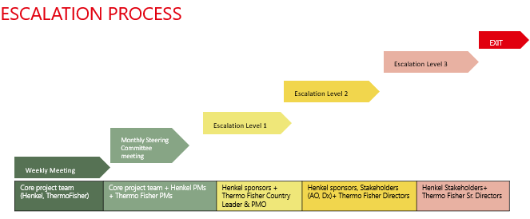

Term
The Services under this Statement of Work shall commence on an agreed date on receipt of a relevant purchase order by the Service Provider unless terminated as provided under the terms of the MLA and conclude upon completion and approval of all deliverables and milestones defined herein.
Thermo Fisher and Henkel will agree on an exit management period if any (partial) termination of services occurs. During an exit management period, the Service Provider shall provide reasonable assistance, co-operation and documentation to assist Henkel in transitioning the services to another Service Provider as a replacement or to Henkel internally always ensuring business continuity. The Service Provider shall be compensated for such exit management services incremental to the normal provision of services on a time basis defined in the rate card.

Charges

Consultancy Fees
The Services are being performed on a time and materials basis. All charge rates specified are exclusive of taxes and as per defined rate card in Appendix A of the MLA and below table.
This SOW is capped to a maximum value of 109,035 EUR for the direct services defined herein for Phase 1. As Phase 1 has been divided into two sub-phases, the total direct service value for Phase 1A amounts to 77,405 EUR, covering three sites: Songdo (South Korea), Waigaoqiao and Kunpeng (China); the total direct service value for Phase 1B amounts to 31,630 EUR, covering two sites: Humen and Danyang (China). In the event that the accrued cumulative charges, including training and time and materials, approach this value, the Service Provider shall promptly notify Henkel. Project teams will then align together in update meeting if additional expenditures need to be added through a change request. For avoidance of doubt, this can only be done in case of scope extensions or scenarios outlined in Section 3.12.
Phase 1A (Songdo, Waigaoqiao, Kunpeng)
Item | Qty | Part# | Description | Unit Price (Euro) | Final Price (Euro)
1 | 89 | INF-19700-SAM | Implementation Services – Implementation Team (China) | 655.00
2 | 16 | INF-19700-SAM | Implementation Services – Project Manager (China) | 795.00
3 | 2 | INF-19700-SAM | Implementation Services – LIMS Consultants (Global) | 945.00
4 | 4 | INF-19700-SAM | Implementation Services – Project Manager (Global) | 1,125.00
TOTAL | 111 |  |  | 77,405

Phase 1B (Humen, Danyang)
Item | Qty | Part# | Description | Unit Price (Euro) | Final Price (Euro)
1 | 31 | INF-19700-SAM | Implementation Services – Implementation Team (China) | 655.00
2 | 10 | INF-19700-SAM | Implementation Services – Project Manager (China) | 795.00
3 | 3 | INF-19700-SAM | Implementation Services – Project Manager (Global) | 1,125.00
TOTAL | 44 |  |  | 31,630

The Service Provider captures and calculates time charges in hours, with a minimum chargeable time unit of one hour, representing 0.125 of a day. Time is invoiced in hours, based on an 8-hour day.
Invoicing
As Phase 1 has been divided into two sub-phases: Phase 1A & Phase 1B.
Phase 1A is capped at a maximum of 77,405 EUR.
Phase 1B is capped at a maximum of 31,630 EUR.
Total Phase 1 is capped at a maximum of 109,035 EUR.
Efforts are charged on monthly time and material basis based on the sprint deliverables decided by the product owner during sprint planning.
At the end of each sprint, project teams shall review the deliverables from Thermo Fisher and Henkel shall upon successful completion of all sprint deliverables give approval.
Upon sprint deliverable approval, invoice can be send from Thermo Fisher to Henkel at the end of each month for the completed work and upfront aligned efforts.
In case of delays / non-acceptance of deliverable, refer to section 3.6. Thermo Fisher team will work on the deliverable issues and confirm the delivery in the next sprint and invoice them.
The Service Provider will invoice the Customer for consultancy fees within 120 days of the date that the sprint was successfully delivered by the Service Provider and accepted by Customer.
Payment follows the agreed payment term in the MLA of 60 days end of month after invoice receipt, payable 5th of the following month.

Travel
The Service Provider will invoice the Customer for travel expenses as actual following the Henkel Travel Policy for Externals as defined in the MLA Annex G.
- In the event that travel expenses allocated for the project are not fully utilized, there is an opportunity to convert the remaining balance into additional services.
- This conversion of unused travel cost into services is subject to the explicit approval of the customer.
- Upon customer approval, the unused travel cost will be reallocated and utilized for the provision of agreed-upon services as outlined in the SOW.
- The decision to convert the unused travel cost into services will be documented and mutually agreed upon by both parties.
- The process for obtaining customer approval and implementing the conversion will be clearly defined in the Change Request process or as per the agreed-upon project governance framework.
- The converted services will be aligned with the scope and objectives of the project, ensuring that they provide value and contribute to the project's success.

Expenses
The Service Provider will not recharge expenses to the Customer.
If at some point during the project it is agreed that certain expenses can be recharged, then a change request will need to be raised to request an increase in budget and a variation in terms, which will need to define the frequency of invoicing and process for requesting Purchase Orders.

Acceptance
AGREEMENT:
By our signature, we agree to the above terms.
IN WITNESS WHEREOF, the Parties have executed this Statement of Work and each acknowledges having received one duly executed original.
The Parties signing this document are assumed to have the necessary authority to agree to the terms set out in this SOW. If the Customer will not be providing purchase orders in respect of the charges set out in this document, then signature of this is assumed to be authorisation for payment in lieu of a Purchase Order.

HENKEL AG & Co. KGaA |  | Thermo Fisher Scientific (China) Co. Ltd
(Customer Signature) |  | (Thermo Fisher Signature)
(Customer Printed Name) |  | (Thermo Fisher Printed Name)
(Customer Title) |  | (Thermo Fisher Title)
(Customer Date) |  | (Thermo Fisher Date)

Appendix A – Delivery Acceptance Form Template
The template document has been inserted as an image in this template. To use the document in context of a project the separate template will be used.
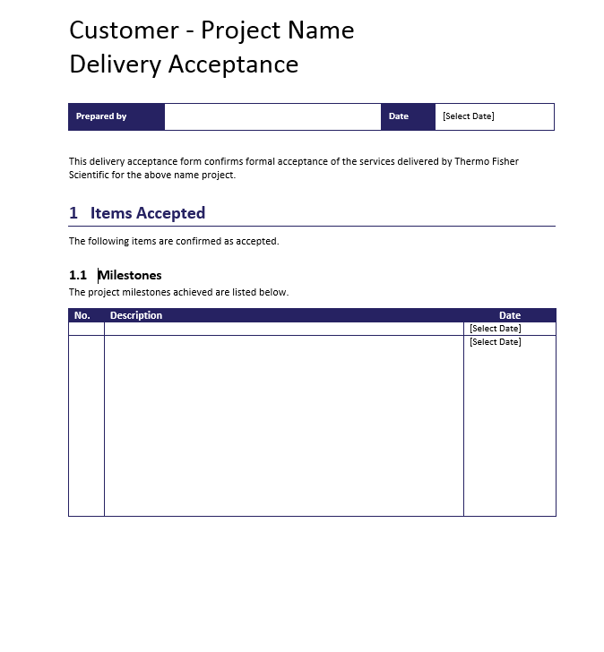
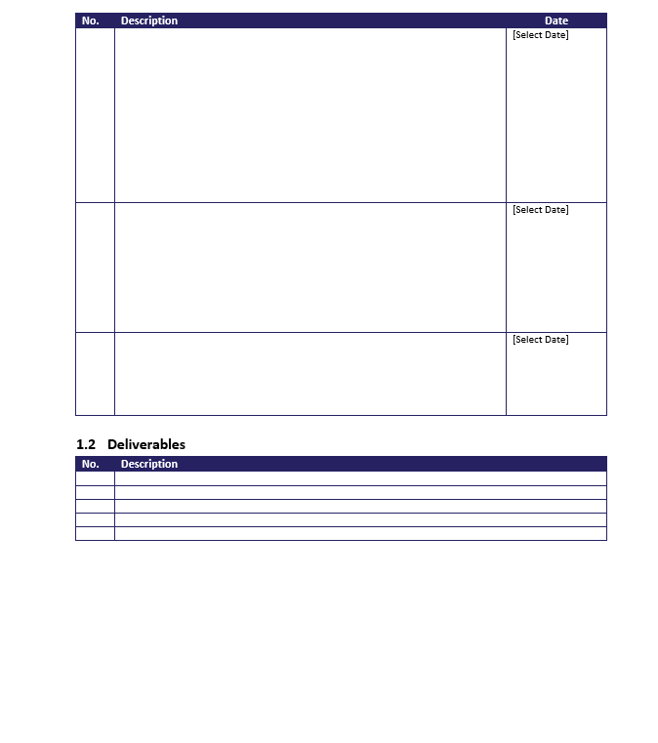
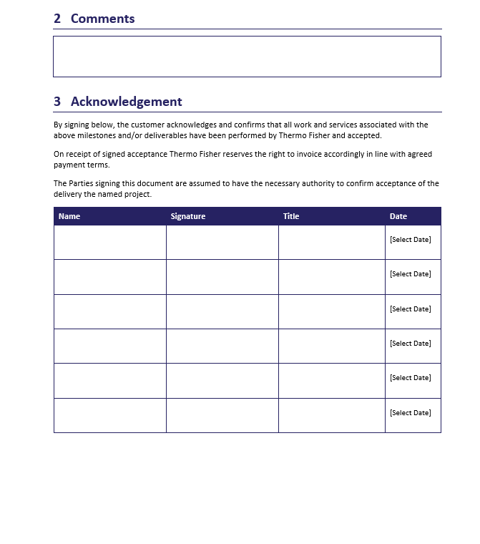

Appendix B – Change Request Template
The template document has been inserted as an image in this template. To use the document in context of a project the separate template will be used.
